Generic Lighting Plan Submission Checklist

Select Key Requirements – Read the Entire Ordinance Before Creating Your Lighting Plan

(1) All outdoor lighting shall be fully shielded.

(2) No luminaire shall create conditions of light trespass. The light source (the bulb or a light-colored lens shall not be visible from any other property. Mounting height or proximity to property lines may cause you to need added shielding.

(2) Light is measured in lumens. Commercial properties are allowed 100,000 lumens per net acre (about 2.2957 lumens/sq ft. ) and residential properties are allowed 25,000 lumens per net acre (about 0.57392 lumens/sq. ft) in any contiguous illuminated area.

(3) Outdoor lighting includes light fixtures installed indoors behind see-through material that allows the light source to be seen from any other property.

Items to include in Lighting Plan for all Outdoor Lighting:

_____ (1) The location and height of all existing and proposed light fixtures. Data for existing fixtures may be estimated but the source of the numbers assigned must be documented.

_____ (2) Manufacturer’s specification sheets for each fixture included in the plan. The specific configuration and any options to be ordered should be indicated on the spec sheet. If specification sheets cannot be located for an existing fixture, then submit daylight photographs of it and nighttime photographs showing the area the fixture illuminates.

_____ (3) Building elevations with notes where light fixtures are to be installed indoors which may be seen from the exterior.

_____ (4) Site plan with specific measurements in feet for the area to be illuminated. A scale notation is not sufficient.

_____ (5) A completed Lumen Calculation Workbook (Excel format) to determine net lumens per square foot. It must include:

_____ (A) The light fixture catalog descriptions including lamp type

_____ (B) The Kelvin rating for the selected lamp

_____ (C) The mounting height for the fixture

_____ (D) The number of fixtures / lamps (use the same unit corresponding to the unit used to determine how many lumens are produced)

_____ (F) The initial lumens for each entire fixture

_____ (H) The LLF or efficiency for the calculation of Luminaire Lumens (Use 0.95 for LEDs and 0.80 for other types of lamps unless a different percentage is documented in manufacturer’s data).

_____ (I) The total square footage of the area to be illuminated.

FIGURES AND ILLUSTRATIONS
FIGURE A:
An illustration of best outdoor lighting practices.

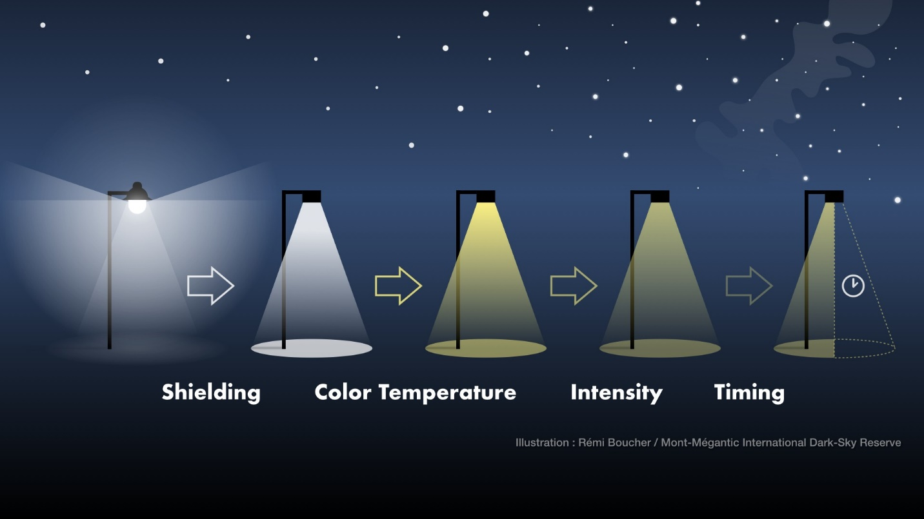

(1) Use shielding to reclaim wasted light and direct it to the area to be lit.

(2) Lower the correlated color temperature (CCT) from “cool” white light to “warm” white.

(3) Lower the intensity to provide as much light as needed for the application, but no more.

(4) Use adaptive controls, e.g., timers, half-night photocells, motion sensors, etc., to limit the hours the light is in use.

FIGURE B:
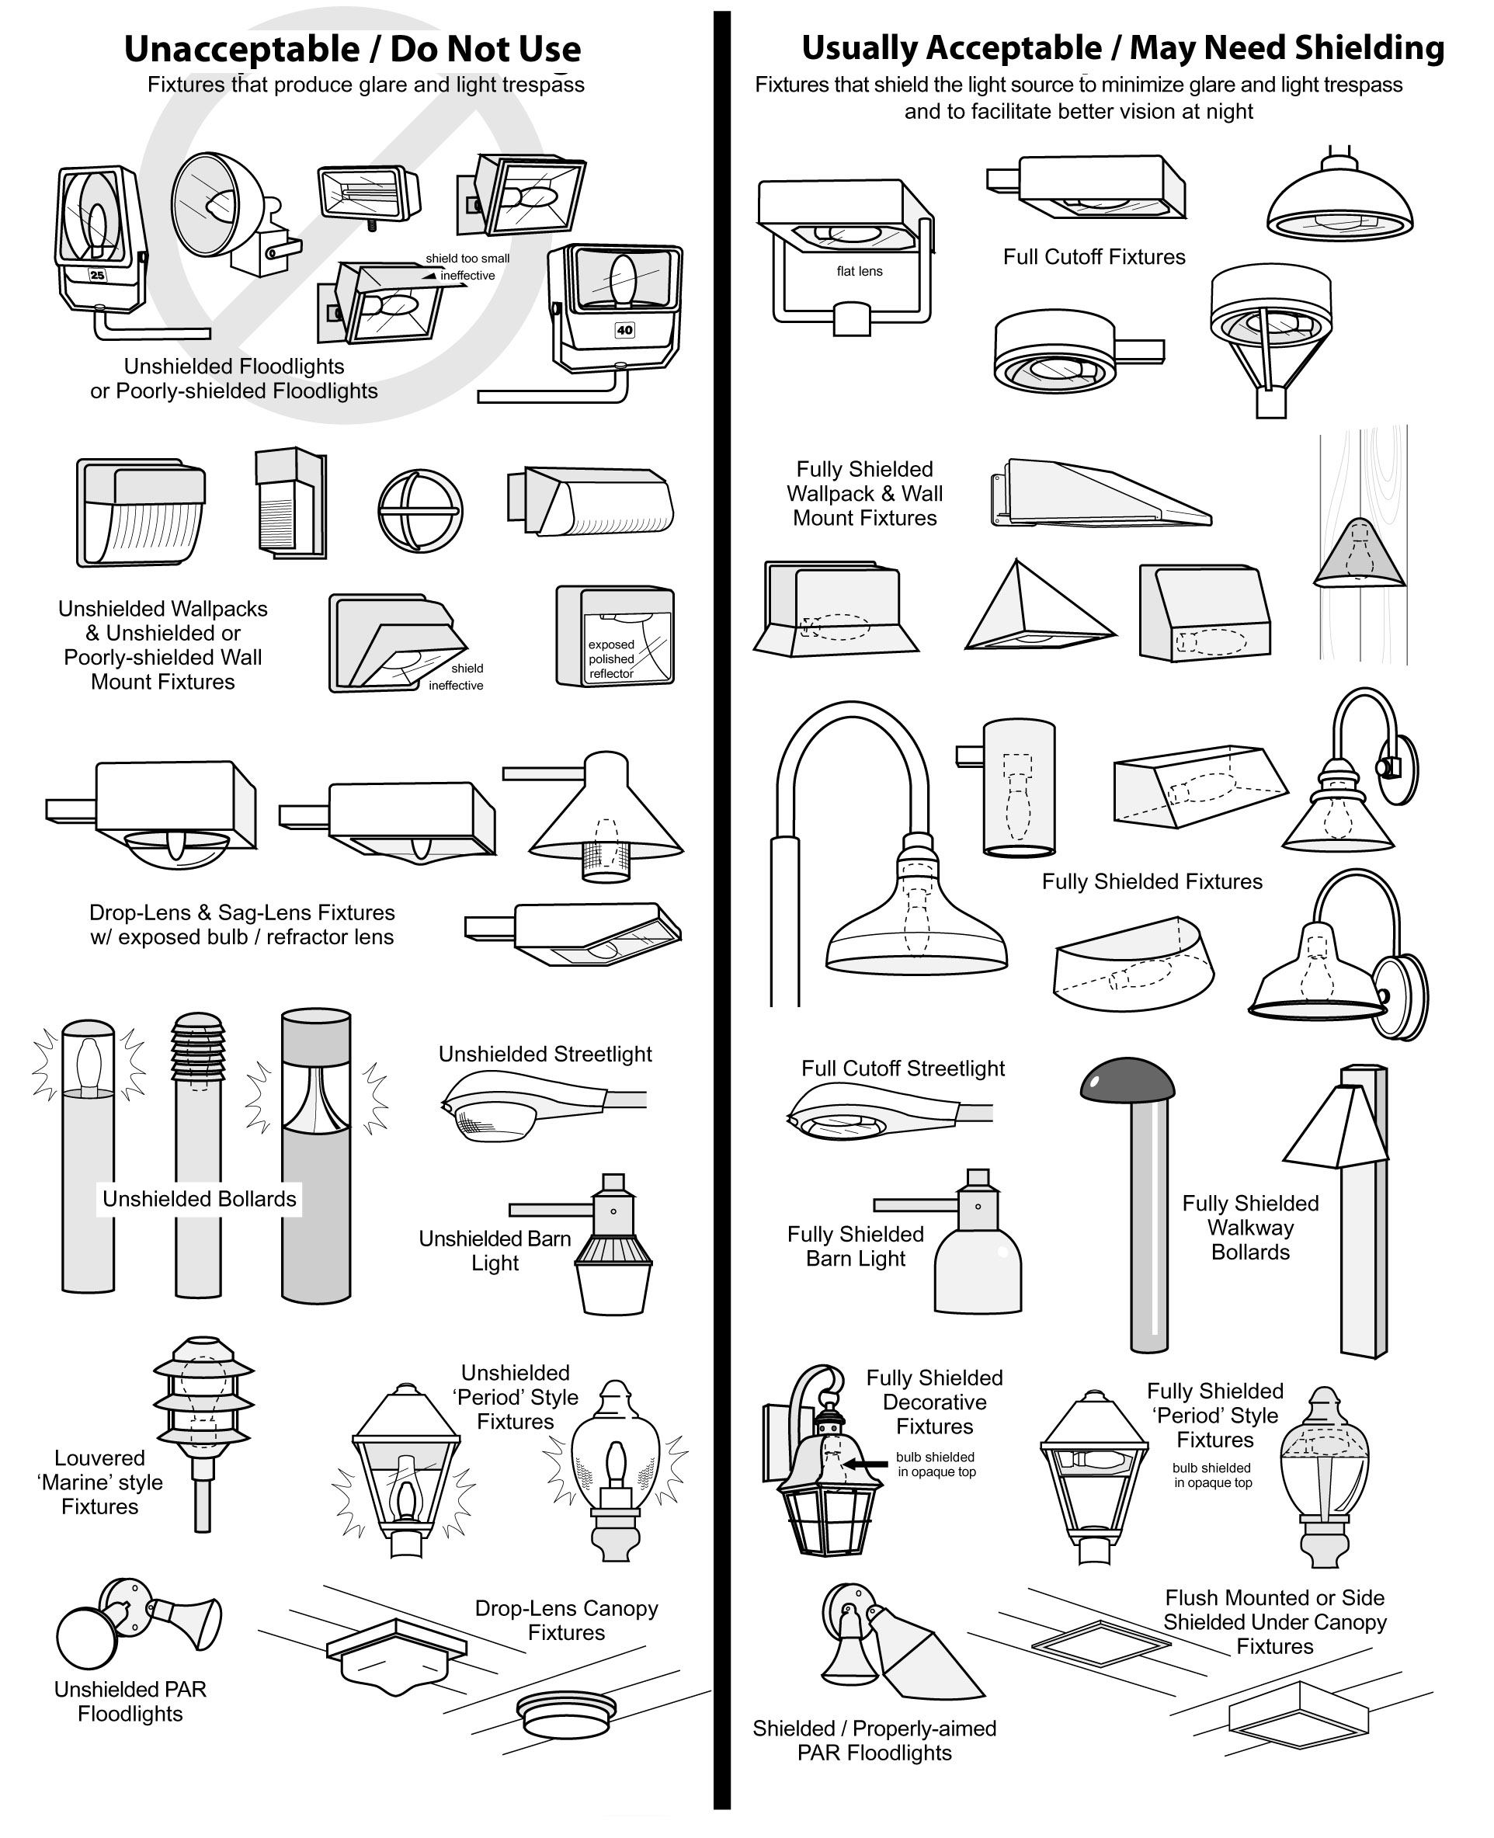

FIGURE C: Sample Lumen Calculation Sheet (Excel sample available on City website)

